Exp. No: 12
Verification of Poynting Theorem and Determination of Energy Flow Using the Poynting Vector
Test Case (i) – Poynting Vector and Poynting Theorem for a Plane Wave in Free Space
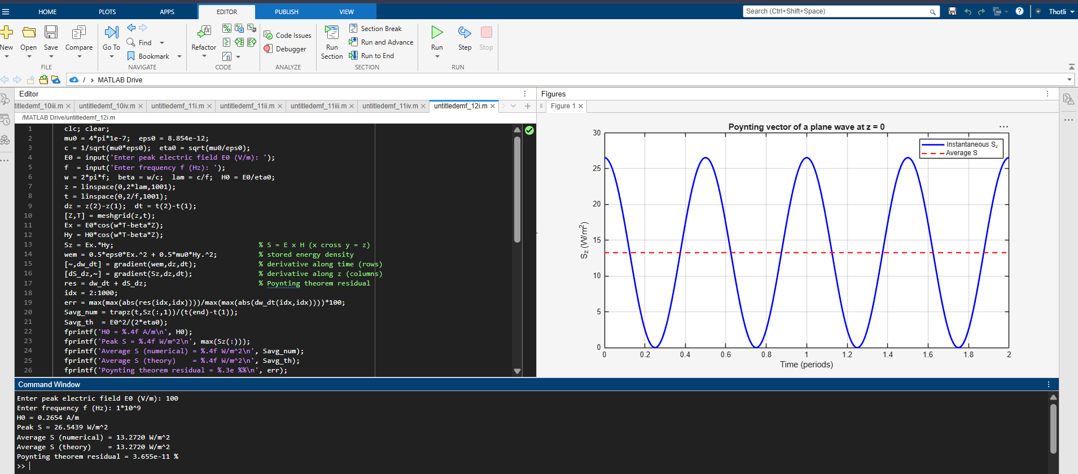
Test Case (ii) – Energy Flow and Power Absorption in a Lossy Medium (Sea Water)
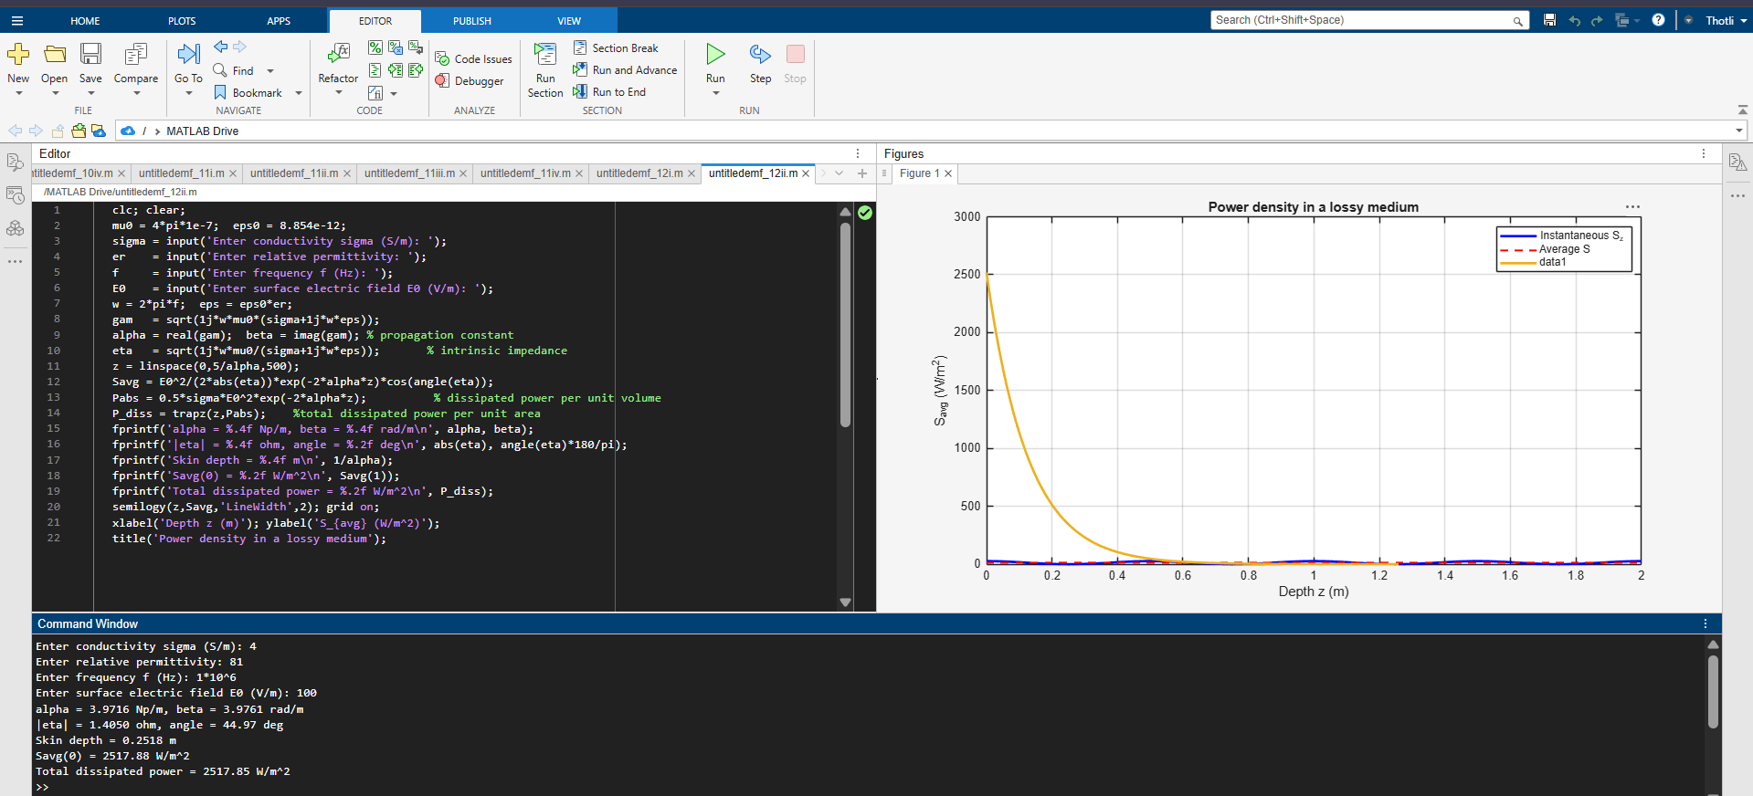

Test Case (iii) – Poynting Theorem for a Current-Carrying Conductor
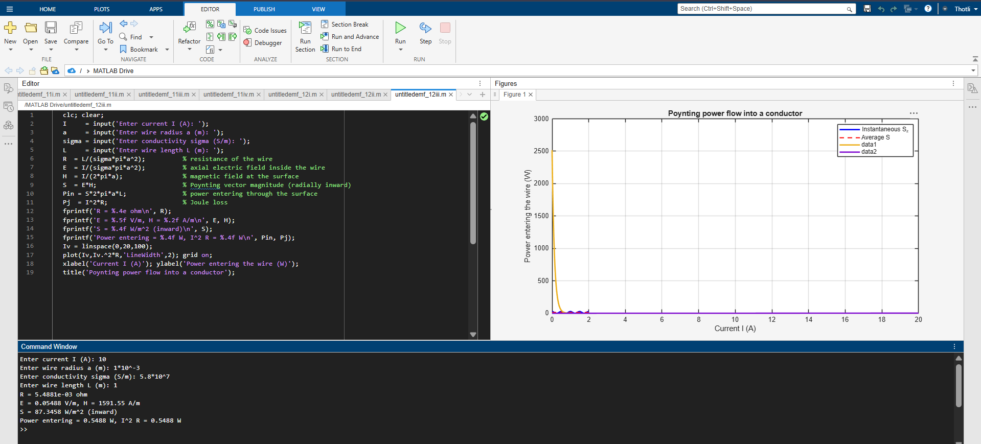
Test Case (iv) – Poynting Vector Analysis for a Solar Panel (IEC 60904 Irradiance)


